The Case of the Toxic Flea Dip ( /16 marks)

You’re working at the medical examiner’s office at San Francisco County Hospital. It has been a particularly light day, with only 1 homicide and a dead chipmunk that you checked over for rabies. The chipmunk didn’t have rabies, and you’re ready to go home. Just as you’re flipping the switch, you get a call from your secretary. “Francesca,” he says. “We’ve got a dead kid up here that you’ll want to look at right away. Might be foul play.”

Thinking of your four-year old daughter waiting for you at home, you grimace. “OK Jon, I’m heading to the morgue.” Performing autopsies on kids is the least favorite part of your job. But you are paid to solve medical mysteries, and it looks like you’ve got one here.

In the morgue, you find the report from the hospital. Glancing over it, you notice a narrative of the girl’s last hours and read it carefully:

At 10 AM, mother returns from the store to find girl vomiting, not feeling well, and sleepy. Mother put girl to bed. Ten minutes later, she noticed that the child’s breathing became irregular and slow. She tried to wake her daughter but was not able to do so. The child became comatose. At noon, the girl was admitted to the hospital, with no heartbeat or spontaneous breathing.

A police report states the following:

The parents discovered that the girl had been giving her dog a bath using a flea dip called Fleacide. According to the label on the container, Fleacide is an insecticide made of plant material only and appropriate for external use on animals.



Part 1: The Flea Dip
Read the text above and answer the following questions.

Priming Questions:
- What could have been in the flea dip that killed the girl?

It is unexpected that rotenone would lead to mortality of a person. However, it is more likely that rotenone caused the death of the girl.

2.How could a product that is normally harmless to humans and pets have killed the girl?

In normal situations, drug tests are run in adults and animals but not children. Therefore, a drug that had no adverse effects on adults could react very differently to the child’s health. Besides, a child’s immune system may probably be underdeveloped and this could play a role in the poisoning and death of the child. There is a possibility that the girl consumed a high dose of the flea dip; that is, she may have swallowed large quantities of the fleacide.

Part 2: Autopsy Report
- The girl died within two hours of first vomiting
- Immediate cause of death was hypoxia (lack of oxygen)
- Tissue sections from the kidneys, lungs, thymus, and heart show massive cell death
- Staining with cellular dyes indicates that the mitochondria within the affected tissues were damaged

Priming Question:
- Given the autopsy report and recalling your knowledge from your reading about the functions of cellular organelles, what functions of the cell did the Fleacide affect?

The massive cell damage in the lungs, the kidney, thymus, and heart are indications that damage occurred at the cellular level. The fact that staining with cellular dyes showed mitochondria damage suggests that aerobic respiration, which occurs at the mitochondria, was disrupted. rotenone has neurotoxic effects. It induces apoptosis which can also cause death.

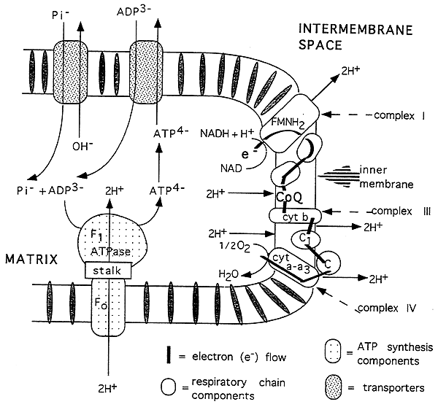

(Image obtained from http://www2.csudh.edu/nsturm/CHE450/Images1-3,25/ElecChain.gif)

Part 3: ATP Analysis
A more detailed analysis of the cells from the girl’s heart showed that ATP levels were reduced in the mitochondria. ATP levels in the cytoplasm of these cells, however, were normal. In addition, acetyl-CoenzymeA levels were normal.

Question:
- What cellular processes (or processes) might have been impaired by the Fleacide? Use diagrams and captions in your explanation. (8 marks: 2 marks for glycolysis, 2 marks for pyruvate oxidation, 2 marks for Citric acid cycle, 2 marks for electron transport chain)

The presence of normal levels of acetyl Coenzyme A is an indication that glycolysis is functioning normally. However, ATP is absent in the mitochondria, an indication that suggests either the Krebs cycle or the electron transport was impaired.
- Glycolysis is the process by which glucose is broken down into two pyruvate molecules. The diagram below shows ten enzyme meditation steps linear pathway. This pathway has an energy generation phase and an energy consumption phase. The first 5 steps are termed as preparation phase, which results in glyceraldehyde 3-phosphate. The last five steps are termed as energy consumption phase and these generate the two final molecules of pyruvate.
- Pyruvate oxidation- pyruvate oxidation takes place in the matrix of mitochondria. Pyruvate is produced during the process of glycolysis in the cytoplasm. The end products of pyruvate oxidation are Coenzyme A, NADH and carbon dioxide.
- Citric acid cycle- in this cycle, an acetyl group from acetyl CoA is attached to four carbon oxaloacetate resulting in the formation of six-carbon citrate molecules. Citrate is later oxidized, thereby releasing two carbon molecules from each of the acetyl groups. The citric acid cycle aims at harvesting high-energy electrons from carbon.
- Electron transport chain- this is a series of protein complexes whose function is to transport protein complexes from the electron donors to the electron acceptors via redox reaction and or across the membrane.

Glycolysis

Glucose ATP
(Hexokinase)
ADP
glucose 6- phosphate
(Phosphoglucoisomrase)

fructose 6-phosphate
(Phosphofructokinase)

Fructose 1,6 bisphosphate

Glyceraldehyde dihydroxyacetone phosphate

(Isomerase)
(2NAD, 2NADH plus 2H)
(Triose phosphate)

1,3-bisphosphoglycerate

3-phosphorate
((Phosphoglyceromutase)
2-phosphoglycerate
(Enolase) (water formed)
Phosphoenolpyruvate
(Pyruvate kinase) (2 ADP, 2ATP)

pyruvate

Part 4: Subcellular Analysis
Using a new chromatographic technology developed late last year, you are able to determine the levels of various subcellular components in the heart cells. Key highlights of the report are listed below:

Metabolite | Autopsy Finding | Normal Levels
Glucose | 102 mmol | 100 mmol
Pyruvate | 23 mmol | 25 mmol
NAD+ | 6 mmol | 75 mmol
NADH | 383 mmol | 50 mmol

Questions:
- Given this new information, what specific cellular process do you think was affected by the Fleacide? Why? Use a simple schematic diagram to support your explanation (4 marks)
The presence of low levels of NAD+ and high levels of NADH is an indication that the first stage in electron transport chains was disrupted. NADH, whose main function is to convert the electron carriers, was likely blocked by the Fleacide.

- Some health food stores sell supplements containing NAD+. If you administered the supplement to the girl, could you save her? Why or why not? (2 marks)
Most likely not. This is because low levels of NAD+ in the heart are not a sign of poisoning. However, rotenone prevents electron transfer from NADH to the electron transport chain by inactivating NADH dehydrogenase. This results in the addition of NAD+ to the cells, which increases NADH but will not restore the normal function of the electron transport chain.

- Would artificial respiration or oxygenation save the girl? Why or why not? (2 marks)

Probably no. Rotenone functions to inhibit the transfer of electrons from NADH to the electron transport chain by first inactivating NADH dehydrogenase. High oxygen concentration cannot solve the defect in the electron transport chain. This question addressed the misconception between respiration and cellular respiration.

